**Lab Report**

Course Name : Electrical Circuits

Course Code : CSE209 LAB

Section No : 04

Experiment N : 01

Experiment name : Introduction to Circuit Elements and Variables.

**Submitted to**

Course instructor : Rashedul Amin Tuhin

Senior lecturer

Computer science and engineering

**Submitted by**

Name: Apurba Roy Ajay

Student’s ID : 2018-3-60-063

Department : Computer Science and Engineering

**Date of report submission : /09/2020**

**Objectives:**

1. To get familiar with circuit variables (voltage and current) and circuit elements (voltage source and resistance).
2. To learn how to measure dc voltage across a circuit element using a voltmeter.
3. To learn how to measure dc current through a circuit element using an ammeter.
4. To learn how to measure resistance of a resistor using a multimeter.
5. To verify Ohm’s Law.

**Circuit Diagram(s):**

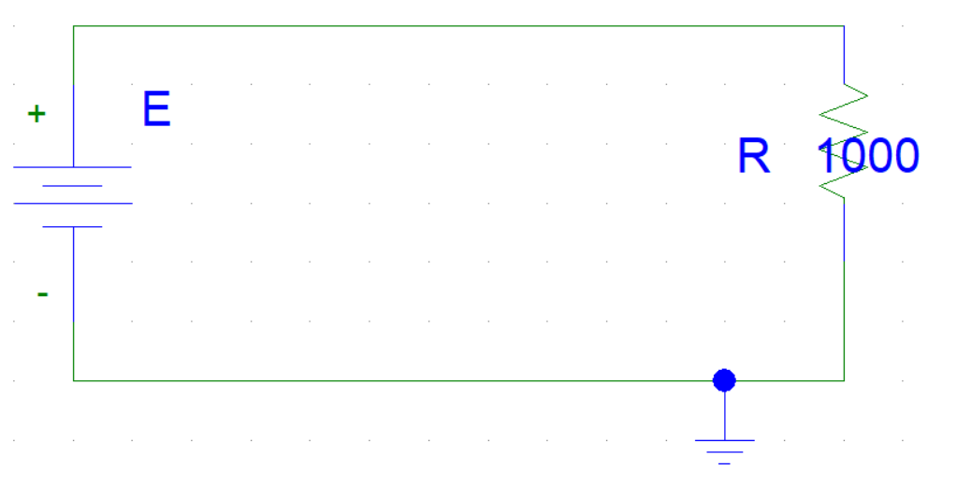

**Experimental Datasheet:**

|  |  |  |  |  |
| --- | --- | --- | --- | --- |
| Observation number | Set Value of  *E* (V) | Measured Value of *V* (V) | Measured Value of *I* (mA) | Measured Value  of *R* () |
| 1 | 5 | 5 | 5 | 1000 |
| 2 | 6 | 6 | 6 |
| 3 | 7 | 7 | 7 |
| 4 | 8 | 8 | 8 |
| 5 | 9 | 9 | 9 |
| 6 | 10 | 10 | 10 |

**Answer(s) to the Post-Lab Report Question(s):**1.answer:   
 we know, $I=\frac{V}{R}$  
 [ohm’s law]

When v=5V and R=1000 $Ω$ $,I=\frac{5}{1000}$ = 5mA.

When v=6V and R=1000 $Ω$ $,I=\frac{6}{1000}$ = 6mA

When v=7V and R=1000 $Ω$ $,I=\frac{7}{1000}$ = 7mA

When v=8V and R=1000 $Ω$, $I=\frac{8}{1000}$ = 8mA

When v=9V and R=1000 $Ω$ $,I=\frac{9}{1000}$ = 9mA

When v=10V and R=1000 $Ω$, $I=\frac{10}{1000}$ = 10mA

I made this circuit through the PsPice software.

2.answer:  
 we know,

$⇒R=\frac{V}{I}$ [ohm’s law]

When V=5V and I=0.005A, $R=\frac{5}{0.005}$ = 1000 $Ω$.

When V=6V and I=0.006A, $R=\frac{6}{0.006}$ = 1000 $Ω$.

When V=7V and I=0.007A, $R=\frac{7}{0.007}$ = 1000 $Ω$.

When V=8V and I=0.008A, $R=\frac{8}{0.008}$ = 1000 $Ω$.

When V=9V and I=0.009A, $R=\frac{9}{0.009}$ = 1000 $Ω$.

When V=10V and I=0.010A, $R=\frac{10}{0.010}$ = 1000 $Ω$.

3.answer:

= I have set some different values of *E* and of *V.* But I can not see any kind of difference of *E* and *V.*

4.answer:

We know, straight line equation is $y=mx+c ;$  
as straight line passing through in origin. So, $y=mx;$  
We know, ohm’s law equation is $V=IR$  
If we compare straight line and ohm’s law, slope m is equivalent to resistor $R$.

From the graph, if we consider two point (5, 5) and (8, 8)

we know,

Slope = $\frac{y_{2}-y_{1}}{x_{2-x_{1}}}$ = $\frac{5-5}{8-8}=1m=1000$  
Here every two points slope is 1000 and Resistor =1000 $Ω$.  
  
I can’t find any difference of calculate value and measure value.

4.answer:

Measuring current using a multi-range meter:

1. Turn the meter on

2. Insert the probes into the correct connections - in many meters there are a number of different connections for the probes. Often one labelled common into which the black probe is normally placed. The other probe should be entered into the correct socket for the current measurement to be made. Sometimes there is a special connection for current measurements, and sometimes a separate one for either low or high current measurements. Select the correct one for the current measurement to be made.

3. Set main selector switch on the meter switch to the correct measurement type, (i.e. current) and range for the measurement to be made. When selecting the range, ensure that the maximum range is above the expected reading anticipated. The range on the DMM can then be reduced as necessary. However by selecting a range that is too high, it prevents the meter being overloaded.

4. When the measuring the current, optimise the range for the best reading. If possible enable all the leading digits to not read zero, and in this way the greatest number of significant digits can be read.

5. Once the reading is complete, it is a wise precaution to place the probes into the voltage measurement sockets and turn the range to maximum voltage. In this way if the meter is accidentally connected without thought for the range used, there is little chance of damage to the meter. This may not be true if it left set for a current reading, and the meter is accidentally connected across a high voltage point!

Measuring voltage using a multi-range meter:

To start, let's measure voltage on a AA battery: Plug the black probe into COM and the red probe into mAVΩ. Set the multimeter to "2V" in the DC (direct current) range. Almost all portable electronics use direct current), not alternating current. Connect the black probe to the battery's ground or '-' and the red probe to power or '+'. Squeeze the probes with a little pressure against the positive and negative terminals of the AA battery. If you've got a fresh battery, you should see around 1.5V on the display (this battery is brand new, so its voltage is slightly higher than 1.5V). Testing a AA Battery with Multimeter If you're measuring DC voltage (such as a battery or a sensor hooked up to an Arduino) you want to set the knob where the V has a straight line. AC voltage (like what comes out of the wall) can be dangerous, so we rarely need to use the AC voltage setting (the V with a wavy line next to it). If you're messing with AC, we recommend you get a non-contact tester rather than use a digital multimeter. Volts DC Use the V with a straight line to measure DC Voltage Volts AC Use the V with a wavy line to measure AC Voltage What happens if you switch the red and black probes? The reading on the multimeter is simply negative. Nothing bad happens! The multimeter measures voltage in relation to the common probe. How much voltage is there on the ‘+’ of the battery compared to common or the negative pin? 1.5V. If we switch the probes, we define ‘+’ as the common or zero point. How much voltage is there on the ‘-’ of the battery compared to our new zero? -1.5V! alt text Now let's construct a simple circuit to demonstrate how to measure voltage in a real world scenario. The circuit is simply a 1kΩ and a Blue super bright LED powered with a SparkFun Breadboard Power Supply Stick. To begin, let's make sure the circuit you are working on is powered up correctly. If your project should be at 5V but is less than 4.5V or greater than 5.5V, this would quickly give you an indication that something is wrong and you may need to check your power connections or the wiring of your circuit. alt text Measuring the voltage coming off of a Power Supply Stick. Set the knob to "20V" in the DC range (the DC Voltage range has a V with a straight line next to it). Multimeters are generally not autoranging. You have to set the multimeter to a range that it can measure. For example, 2V measures voltages up to 2 volts, and 20V measures voltages up to 20 volts. So if you've measuring a 12V battery, use the 20V setting. 5V system? Use the 20V setting. If you set it incorrectly, you will probably see the meter screen change and then read '1'. alt text With some force (imagine poking a fork into a piece of cooked meat), push the probes onto two exposed pieces of metal. One probe should contact a GND connection. One probe to the VCC or 5V connection. We can test different parts of the circuit as well. This practice is called nodal analysis, and it is a basic building block in circuit analysis. By measuring the voltage across the circuit we can see how much voltage each component requires. Let's measure the whole circuit first. Measuring from where the voltage is going in to the resistor and then where ground is on the LED, we should see the full voltage of the circuit, expected to be around 5V. alt text We can then see how much voltage the LED is using. This is what is referred to as the voltage drop across the LED. If that doesn't make sense now, fear not. It will as you explore the world of electronics more. The important thing to take away is that different parts of a circuit can be measured to analyze the circuit as a whole. alt text This LED is using 2.66V of the available 5V supply to illuminate. This is lower than the forward voltage stated in the datasheet on account of the circuit only having small amount of current running though it, but more on that in a bit.

**Conclusion:** We connect this circuit using Pspice software.I think if we could do this same experiment in the lab, the measure value would change a little bit and most importantly we could learn how to connect the circuit for real life.